

**CSF 3133: Antara Muka Laman Web**

**Lab Report 7**

**Name: CHONG YU**

**Matric No.: S76136**

**Group: K4**

**Program:**

**Computer Science (Software Engineering)**

**Activity 7.1**

Code:

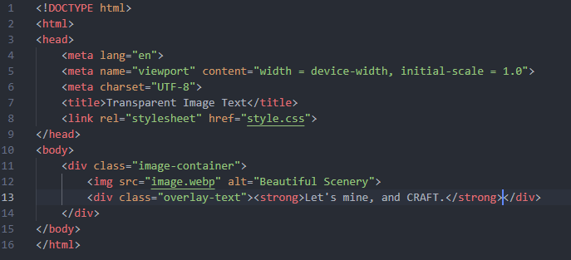

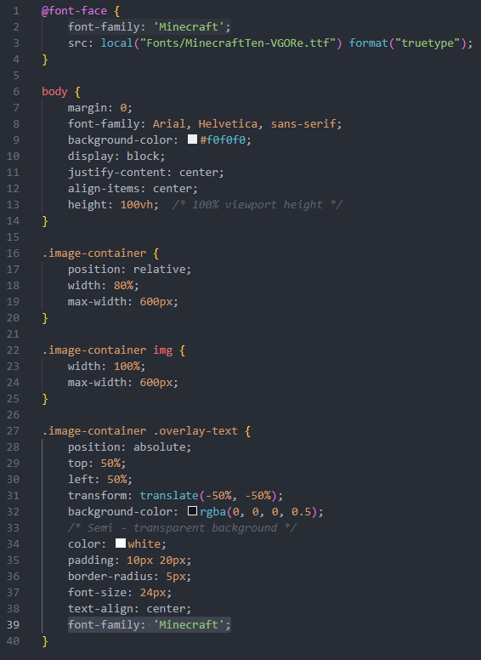

Output:

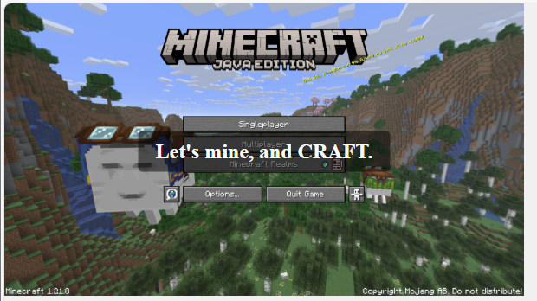

**Activity 7.2**

Code:

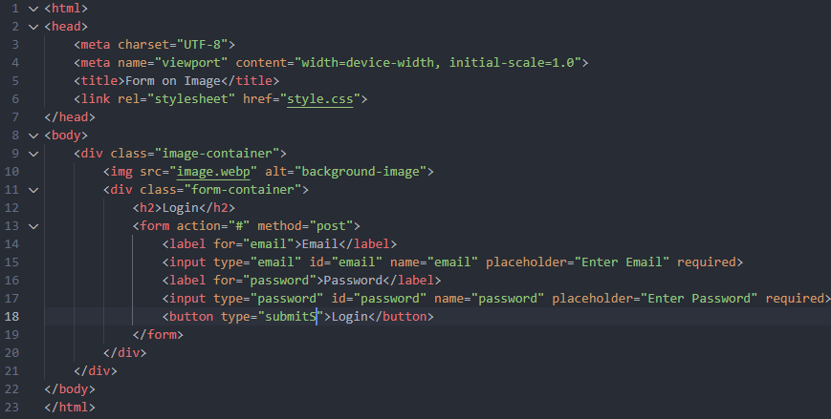

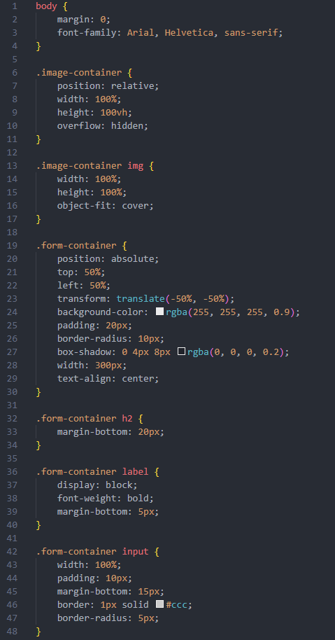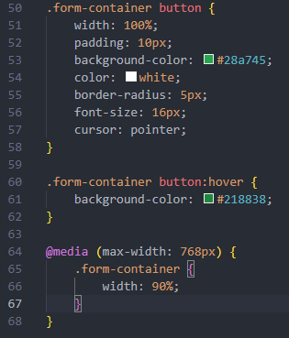

Output:

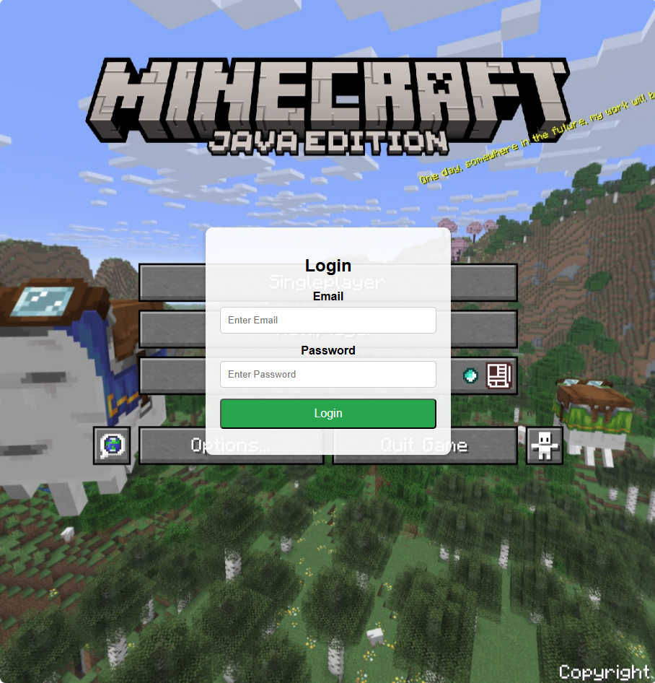

**Activity 7.3**

Code:

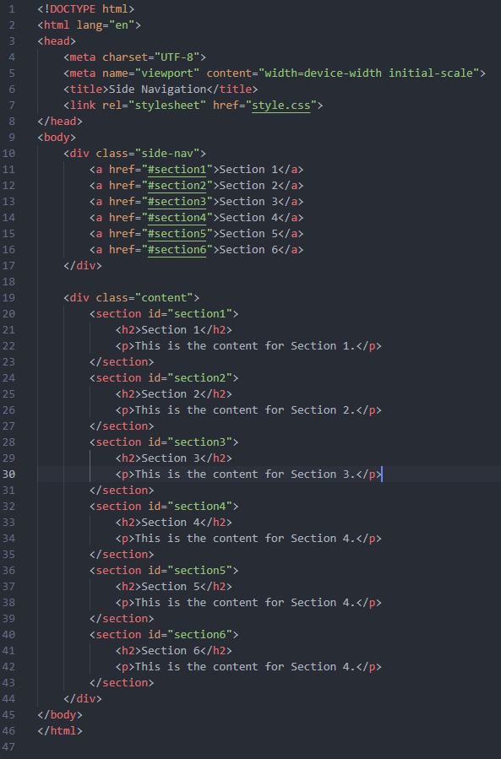

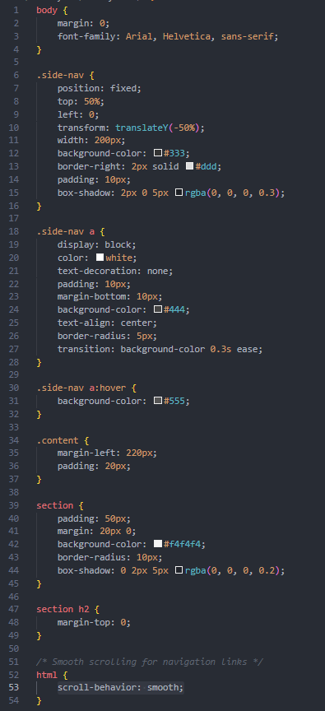

Output:

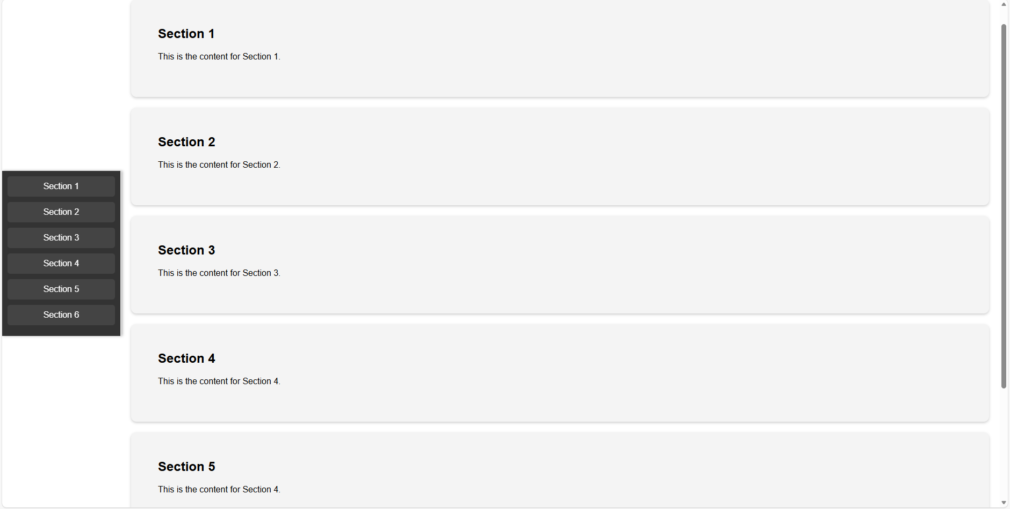

**Activity 7.4**

Code：

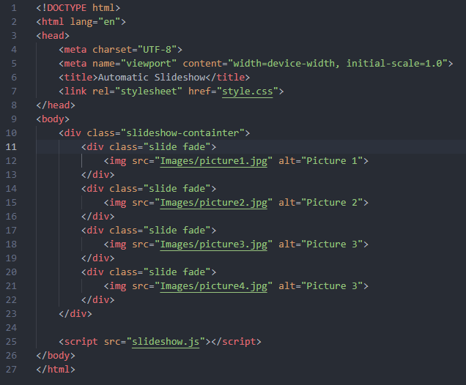

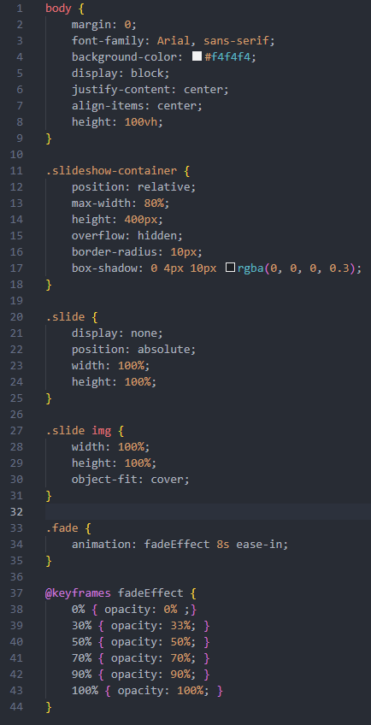

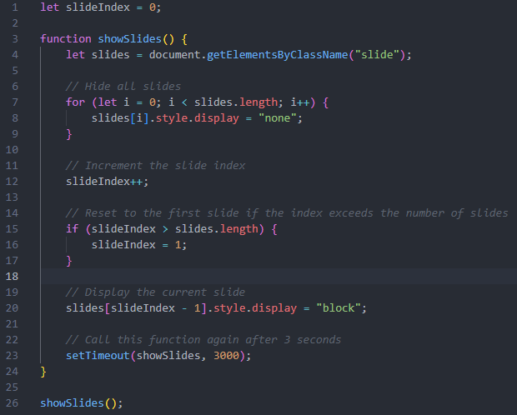

Output: 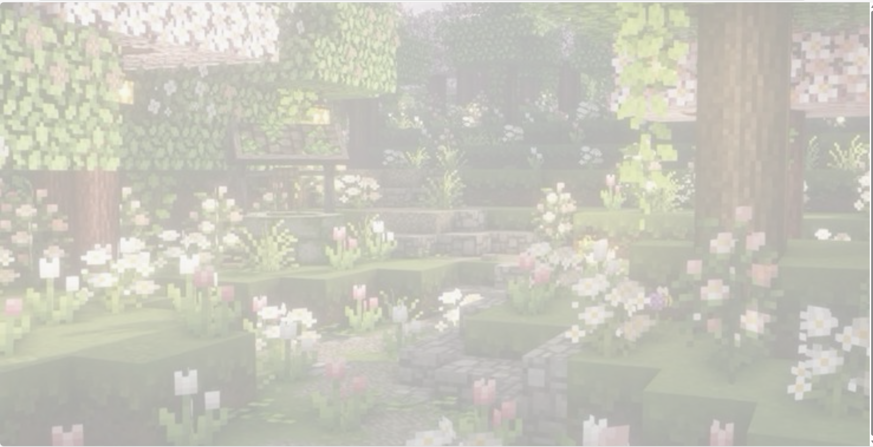

**Activity 7.5**

Output:

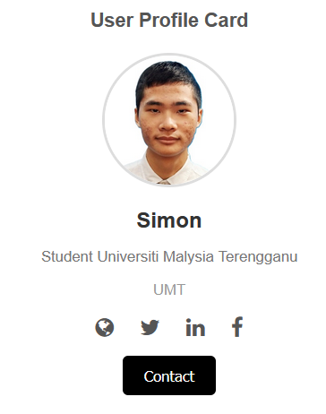

**Activity 7.6**

Code:

Output:

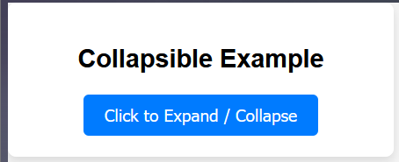

**Activity 7.7**

Code:

Output:

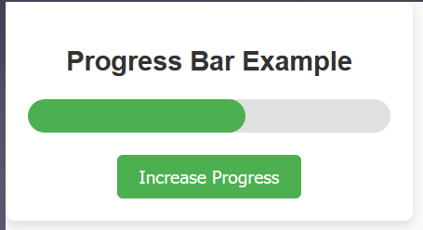

**Lab Exercise**

Code:

Output:

**Lab exercise:**

Output:

